Direct Debit form Internet Donation

I’d like to help Moghissi Laser Trust
with a Direct Debit of £________

Please state your preferred donation dates: 1st or 15th of each month /
quarterly / annually

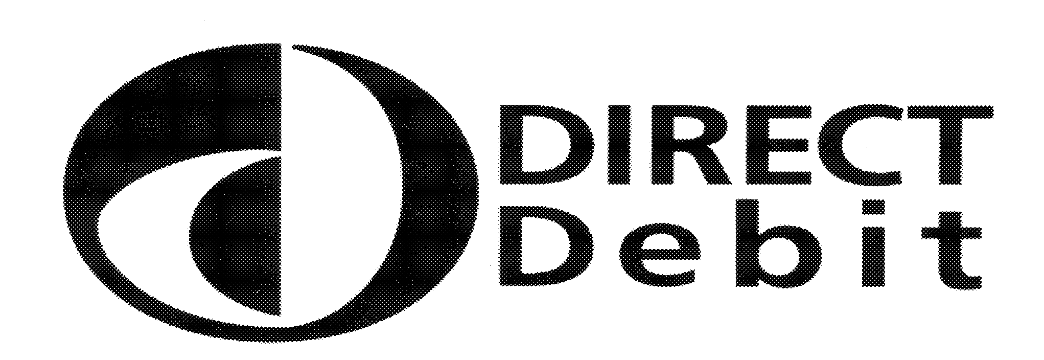

Originator’s identification number

Instruction to your Bank or Building Society to pay Direct Debit.

Please fill in the form in black ink and return to:
Moghissi Laser Trust
Goole and District Hospital
Woodland Avenue
Goole DN14 6RX

To the Manager (name of Bank or Building Society)

______________________________________________________

______________________________________________________

______________________________________________________

______________________________________________________

Name of Account Holder(s)_______________________________

Account number ________________________

Sort code __________________
6
For Moghissi Laser Trust use only. Moghissi Laser Trust reference number.

Instructions to your Bank or Building Society:
Please pay Moghissi Laser Trust Direct Debits from the account detailed in this instruction subject to the safeguards assured by the Direct Debit Guarantee. I understand that this instruction may remain with Moghissi Laser Trust and if so, details will be passed electronically to my Bank or Building Society.
Signature_______________________________ Date_______________

Banks and Building Societies may not accept Direct Debit instructions for some types of account.
_ _ _ _ _ _ _ _ _ _ _ _ _ _ _ _ _ _ _ _ _ _ _ _ _ _ _ _ _ _ _ _ _ _ _ _ _ _ _

Your name________________________________________________________

Your address______________________________________________________

_________________________________________Postcode_______________

Please post all forms to the Moghissi Laser Trust

The Direct Debit guarantee 
- This Guarantee is offered by all Banks and Building Societies that take part in the Direct Debit Scheme.
- The efficiency and security of the Scheme is monitored and protected by your own Bank or Building Society.
- If the amounts to be paid or the payment dates change, Moghissi Laser Trust will notify you 10 working days in advance of your account being debited or as otherwise agreed.
- If an error is made by Moghissi Laser Trust or your Bank or Building Society, you are guaranteed a full and immediate refund from your branch of the amount paid.
- You can cancel a Direct Debit at any time by writing to your Bank or Building Society. Please also send a copy of your letter to us.

Giftaid it

Make your gift worth more at no extra cost to you! Are you a UK taxpayer? If so we can reclaim approximately 28p from the taxman for every £1 you give to Moghissi Laser Trust. It’s simple – just tick the box to help us support more people with cancer across the UK.

Yes! Gift Aid my donation please.

I am a UK tax payer and I would like this donation, all donations I have made to The Laser Trust Fund (Moghissi) for the six years prior to this year, and all donations I make in the future until I notify you otherwise, to be treated as Gift Aid donations. *

I am not a UK tax payer.

* For every £1 you donate to Moghissi Laser Trust in a financial year, you must have paid 28p in income or capital gains tax in the same financial year to qualify for Gift Aid.

Data Protection
Your personal details will be used solely by Moghissi Laser Trust and our authorised agents for research purposes and to advise you of additional fundraising opportunities/news that we think may be of interest. Please tick here if you do not wish this to happen

We can, on occasion, raise more funds for people with cancer by allowing other, carefully selected, organisations to contact you. Please tick here if you do not wish this to happen.

Please post all forms to Moghissi Laser Trust
Goole and District Hospital
Woodland Avenue
Goole
East Yorkshire
DN14 6RX

Thank you

